44.26: a)
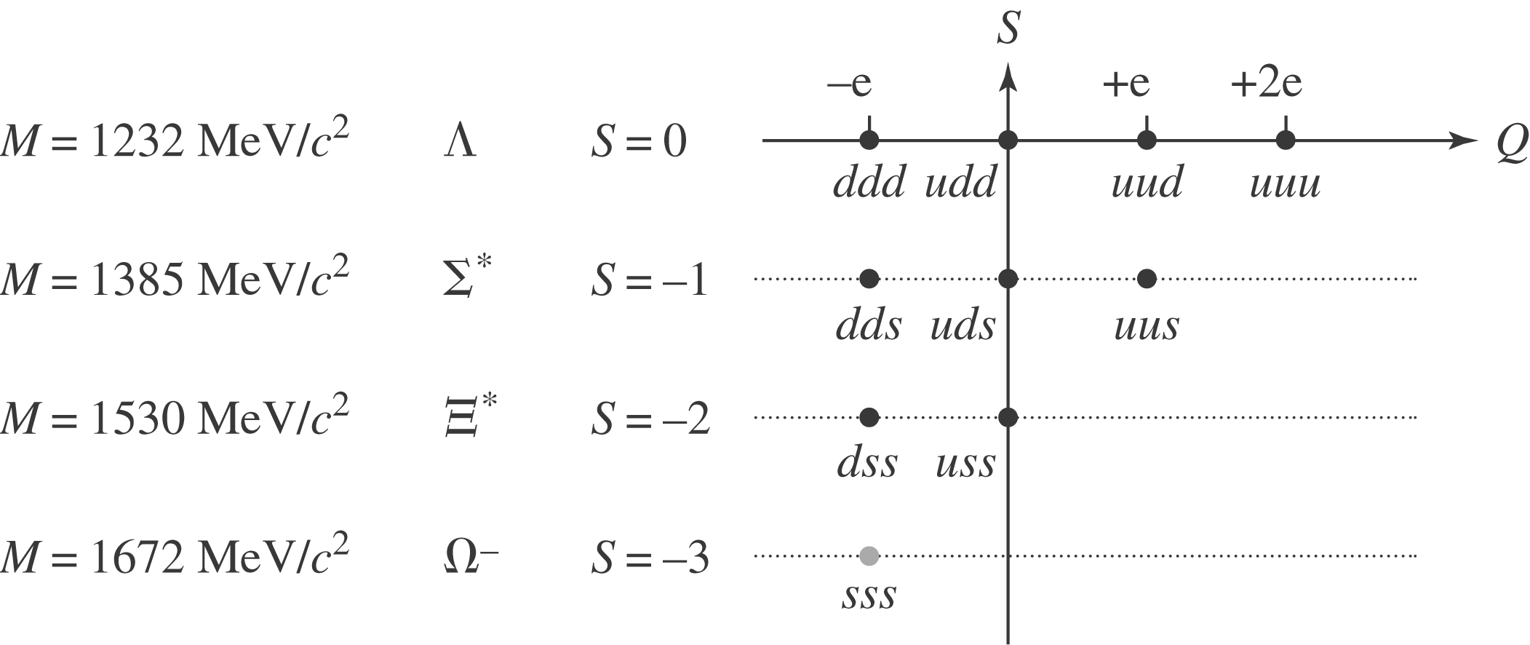

The 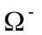 particle has 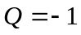 (as its label suggests) and 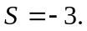 Its appears as a “hole”in an otherwise regular lattice in the 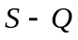 plane. The mass difference between each row is around 145 (or so). This puts the mass at about the right spot. As it turns out, all the other particles on this lattice had been discovered already and it was this “hole” and mass regularity that led to an accurate prediction of the properties of the !
b) See diagram. Use quark charges 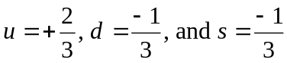 as a guide.

